Documentation of MATLAB project for   
“Pipe Inspection using SEA Snake Robot”

**Oct. 2016**

**Dong-Hyung Kim** ([fileman@hanyang.ac.kr](mailto:fileman@hanyang.ac.kr) or [braikin@hanmail.net](mailto:braikin@hanmail.net) )

# Introduction

This document is to give instruction on how to operate SEA snake robot with included MATLAB codes. All the codes are written by MATLAB which is developed by the author and supporting such as HEBI’s libraries and HebiPlotter (kinematic simulator of SEA snake robot) are given with the codes. These set of codes and supporting is called as the MATLAB project. The MATLAB project was developed for a specific application using SEA snake robot, such as the pipe inspection. And the given codes can be used to run not only the robot but also the simulation using HebiPlotter. That is, user just executes the MATLAB project and then select between the experiment and the simulation.

|  |
| --- |
| **Remark)** MATLAB R2013b or newer version is required. And USB-type gamepad (i.e., Logitech Dual Action) must be connected to your PC or laptop, otherwise MATLAB will show you an error message when you run the MATLAB project |

The operation mode for the SEA snake robot can be categorized according by the target pipe and locomotion gait (Table 1.1). Two operation modes, the ground locomotion and the outer-pipe inspection are provided from the current MATLAB project. For the ground locomotion, the existing gaits presented in [1], [5]-[6] such as sidewinding, slithering, lateral rolling, conical sidewinding, and turn-in-place are implemented in the code. And the outer-pipe inspection is actually about the climbing the pipe. This operation mode is based on the rolling helix gait [4] that the robot climbs up the pipe by forming itself into a helical shape around the pipe, or crawl the gap between two adjacent horizontal pipes. Motivated by [2]-[3], the compliant control based on torque feedback is applied so that the robot can pass through a bent pipe or two connected pipe of different diameter. With these existing gaits, the new gaits for the outer-pipe inspection are developed as follows: the rotating in place, the shifting from pipe to pipe.

Table 1.1 Summary on operation modes and locomotion gaits



# How to run MATLAB project

Copy all the mandatory files to your arbitrary folder as shown in below:

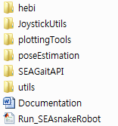

Open ‘*Run_SEAsnakeRobot.m*’ via MATLAB’s Editor and then run this. You may see the following display in the command window

|  |
| --- |
| -------- Pipe Inspection using SEA Snake Robot ----------  API: sdk0.5-rev1424  Tool: Hebi Plotter  -----------------------------------------------------------  Select simulation or experiment (s = simulation, e = experiment) : |

Type ‘s’ or ‘e’ to select the simulation or the experiment. The following is next step for each mode:

(Simulation) You also need to type the number of modules consist of the SEA snake robot. This number should be natural number larger than four. Then a new figure will appear on screen which displays the SEA snake robot.

(Experiment) Make sure that the SEA snake robot is connected well before you run the experiment. The number of modules is automatically determined by its feedback via network thus you can see the discovered number of modules on the command windows.

Now you are ready to move the robot and see the details on the joystick operation at the next section.

# Joystick operation

Once a user run the MATLAB project, the ground locomotion is selected as the default mode. The joystick button number ‘10’ is to return to the ground locomotion. And pressing both button number ‘9 (shift)’ and button number ‘10’ terminates the MATLAB project (Fig. 3.1). This approach is prefered to exit the program than Ctrl + C, especially in the experiment, since the robot goes limps.

## 3.1 Ground locomotion



Figure 3.1 Joystick operation instruction: ground locomotion

The ground locomotion is the movement of SEA snake robot on the ground. You can drive the robot forward, backward, left and right by pressing buttons ▲, ▼, ◀, and ▶ on the D-pad, respectively. For this movement, the robot executes the slithering or the sidewinding. And you can roll the robot sideway by pressing button number ‘5’ or button number ‘6’ where this gait is called by the lateral rolling.

For a rotation of the robot, move the left or right analog sticks to the left or right. Here the left analog joystick enables the conical sidewinding that the robot rotates on its head. And the right analog joystick make the robot turn-in-place. This turn-in-place gait is one kind of sidewinding motions.

To control the speed of robot’s movement, press the button number ‘7’ or the button number ‘8’, where ‘7’ is to speed up and ‘8’ is to slow down. And as an advanced function, you can change the magnitude of the wave function with the button number from ‘1’ to ‘4’.



Figure 3.2 Joystick operation instruction: head look

Click the right analog stick to enable the head look mode, and click again to disable this mode and return to the ground locomotion. The MATLAB project displays whether the head look mode is turned on or off via the command window. And this mode stops the robot moving except four modules starting from the head. User can move and rotate the head consist of these four modules by using the left and/or right analog sticks. And since the robot moves without the aid of a fixed base, the direction of head’s movement does not correspond to the desired direction of the head determined by the analog stick.

## 3.2 Outer-pipe inspection

* **Rolling helix**



Figure 3.3 Joystick operation instruction: outer-pipe inspection, rolling helix

The rolling helix gait is used for inspecting all type of pipes. Start the operation mode ‘outer-pipe inspection’ by pressing both the button number ‘9 (shift)’ and the button number ‘4’. Next you should select the direction of the pole, the left or the right. For this, hold the direction of the pipe from the robot on the D-pad (◀ or ▶) and press the button number ‘1’. Then the robot changes its shape to a curve with large radius. Now press the button number ‘5’ to tighten or the button number ‘6’ to loosen. Once you make the robot grips the pipe, press the up button or the down button on the D-pad to climb up or down.

In this rolling helix gait, the speed of robot’s movement can be controlled by pressing the button number ‘7’ to slow down or the button number ‘8’ to speed up. And you can exit the outer-pipe inspection and return to the ground locomotion by pressing the button number ‘10’. However, do not try this while too high on the pipe.

* **Head look mode**

The head look mode can be entered at any point, from all gaits during the outer-pipe inspection. This is same from the head look mode of Sec. 3.1. See that section and Fig. 3.2.

* **Rotating in place**



Figure 3.4 Joystick operation instruction: rotating in place

This is to rotate the robot in place while the robot travels the pipe. Hold the button number ‘9 (shift)’ and press the button number ‘5’ to enter the rotating in place mode. Repeat this to terminate and return to the rolling helix gait. During the rotating in place mode, rotate the robot by pressing the left or the right on the D-pad.



Figure 3.5 SEA snake robot rotating in place

Figure 3.5 shows the snapshots that the robot rotates around the pipe. This rotation allows you all around view from the head camera. That is, even you can use the head look mode to move the head and change the camera’s view, the robot need to be rotated along the pipe to see the opposite side of the pipe.

* **Crawling between two pipes / Shifting from pipe to pipe**



Figure 3.6 Joystick operation instruction: crawling between pipes

The crawling in this section means that the robot moves along the gap between two adjacent horizontal pipes as shown in Fig. 3.7. This is another use of rolling helix gait. Note that the crawling between pipes mode is sub-function of the rolling helix gait which means you can run this mode after the rolling helix gait.

To run this mode of crawling between pipes, click the left analog joystick and check the command window displaying ‘Pipe Crawling mode On’. Then press the button number ‘5’ to decrease the radius of helix or the button number ‘6’ to increase the radius of helix. And also press the button number ‘3’ to stretch or the button number ‘2’ to shrink. Here the stretching or the shrinking corresponds to the increasing or decreasing the pitch of the helix. For the ease use, you may control both the radius of helix and the stretching or the shrinking at the same time. For example, press both the button number ‘3’ and ‘5’, or any other combination of decreasing/increasing radius and shrinking/stretching. Click the left analog stick again to exit this mode.

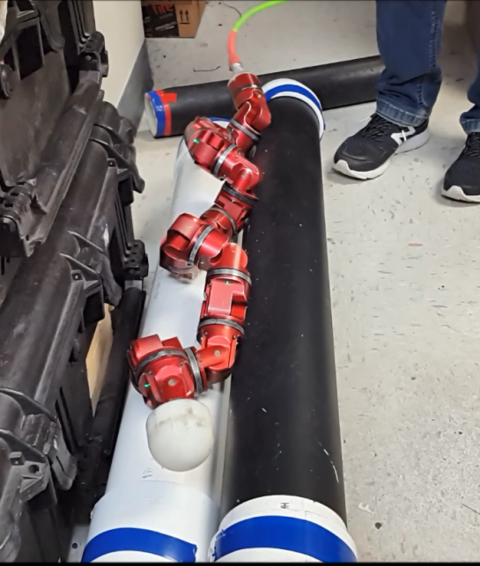

Figure 3.7 Robot moves along the gap between two pipes



Figure 3.8 Joystick operation instruction: shifting from pipe to pipe



Figure 3.9 Robot shifting to another gap between pipes on the left side.



Figure 3.10 Robot shifting to another gap between pipes on the right side.

As a sub-function of the crawling between two pipes, the shifting from pipe to pipe is to move the robot to another gap between two adjacent horizontal pipes. Figure 3.9 shows an example of this mode that the robot moved to the left. This gait first enlarges the radius of helix at the head to put the robot’s head (or the tail) to another gap. And then propagates the enlarged radius of helix from the head to the tail, which means the robot moves its body from the head to the tail to another gap on the left side. In opposite direction, to shift the robot right, the enlarged radius of helix should be propagated from the tail to the head (Fig. 3.10).

To run this gait, hold the button number ‘1’ and press the forward or the backward on the D-pad. Be sure that the head (or the tail) of the robot towards the gap where the robot will be shifted. This is totally human-controlled motion so the robot may fail to shift the pipe or stuck onto the pipe.

# References

1. M. Tesch, K. Lipkin, I. Brown, R. Hatton, A. Peck, J. Rembisz and H. Choset, Parameterized and Scripted Gaits for Modular Snake Robots, *Advanced Robotics*, vol. 23, no. 9, pp. 1131–1158, 2009.
2. D. Rollinson, Control and Design of Snake Robots, Doctoral dissertation, Carnegie Mellon University, 2014.
3. D. Rollinson and H. Choset, Gait-Based Compliant Control for Snake Robots, *2013 IEEE International Conference on Robotics and Automation (ICRA)*, pp. 5123– 5128.
4. W. Zhen, C. Gong, and H. Choset, Modeling Rolling Gaits of a Snake Robot, *2015 IEEE International Conference on Robotics and Automation (ICRA)*, pp. 3741–3746.
5. X. Xiao, E. Cappo, W. Zhen, J. Dai, K. Sun, C. Gong, M. J. Travers, and H. Choset, Locomotive Reduction for Snake Robots, *2015 IEEE International Conference on Robotics and Automation (ICRA)*, pp. 3735–3740.
6. C. Gong, R. L. Hatton, and H. Choset, Conical sidewinding, *2012 IEEE International Conference on Robotics and Automation (ICRA)*, pp. 4222–4227.